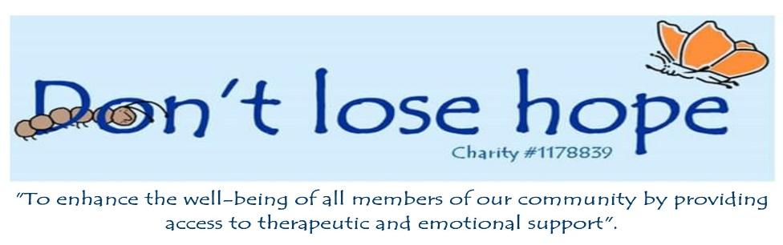

27th June 2019

Dear sir/madam

I am writing to inform you of a new support/therapy group being set up in Bourne by Don’t Lose Hope. The group is for young people who are transgender and are already living as their chosen gender.

The group will be facilitated by Madison Amy Webb who is a woman with a trans history. She is a BACP Accredited Counsellor, Psychotherapist, MBACP, and on the Voluntary Register for therapists. She is a Clinical Supervisor, Mental health Trainer & Consultant. She splits her time between working in Private Practice & Consultancy, training and writing on gender identity and mental health related matters. She has considerable experience exploring her own Gender Identity and supporting others with their own issues.

The group will meet on a Monday evening once a month between 7 and 8.30pm. They will have the opportunity to be able to explore and talk about their feelings, hopes and fears in an environment with other young people who are transitioning. The group members will be given the opportunity in the first meeting to discuss how they would like the group to run and what they would like to cover in future sessions. We hope the group will be approximately 8 young people from age 12 to 17 years old.

The group will be held at the Don’t Lose Hope building and while the young people are in a designated group therapy room the parents/guardians will have the opportunity to have refreshments and talk to each other in the café if they wish. This will be facilitated by Nicola Brister who is a school counsellor and has worked with several transgender young people over the last two years.

There will be no charge for this group as Nicola, Madison and the charity feel it is an area where both young people and their parents have a lack of support and they would like it to be accessible to everyone. The first date will be 29th July.

Please email with any questions [Nicola@dontlosehope.co.uk](mailto:Nicola@dontlosehope.co.uk) or call 01778 420762.

Kind regards

Nicola Brister

4 North Street, Bourne, Lincolnshire, PE10 9EB

enquiries@dontlosehope.co.uk

[www.dontlosehope.co.uk](http://www.dontlosehope.co.uk)

01778 420762