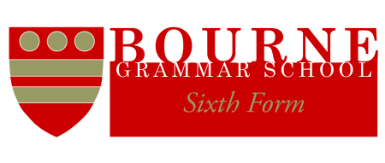

Head Students 2024-25

I am pleased to announce the following appointments for the School Year 2024/2025.

Head Students
Sanjani Mamillapalle
Jack Knowles

Deputy Head Students

Ben Aldred
Elizabeth Burrows
Grace Burrows
Abigail Heywood
Hermione King
Imogen Leaton
Sasha Milne
Courtney Pudney
Harrison Smith

Alastair Anderson
June 2024

