Feeling more worried or anxious than usual?

You are not alone, and know that it is very normal for when we are living with uncertainty, as we are during this pandemic.

The good news is, that there are lots of things you can do to help yourself with these feelings. By practising and discovering methods that help you when you are feeling worried, you will also be preparing yourself for the future. Being able to manage your own emotions is all part of growing up.

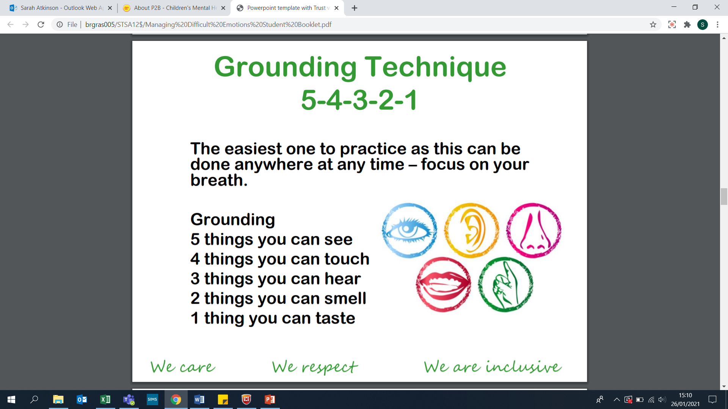

Below are a list of resources and techniques that are proven to help anxious feelings. However, what we cannot tell you, is exactly which methods will help you – you are unique, and different individuals respond to different techniques. Therefore, for these to work, you will need to practise and try out different strategies until you find the ones that work for you.

**Self-help techniques for feelings of anxiety/worry**

1. Relaxation Methods
2. Talking
3. Exercise

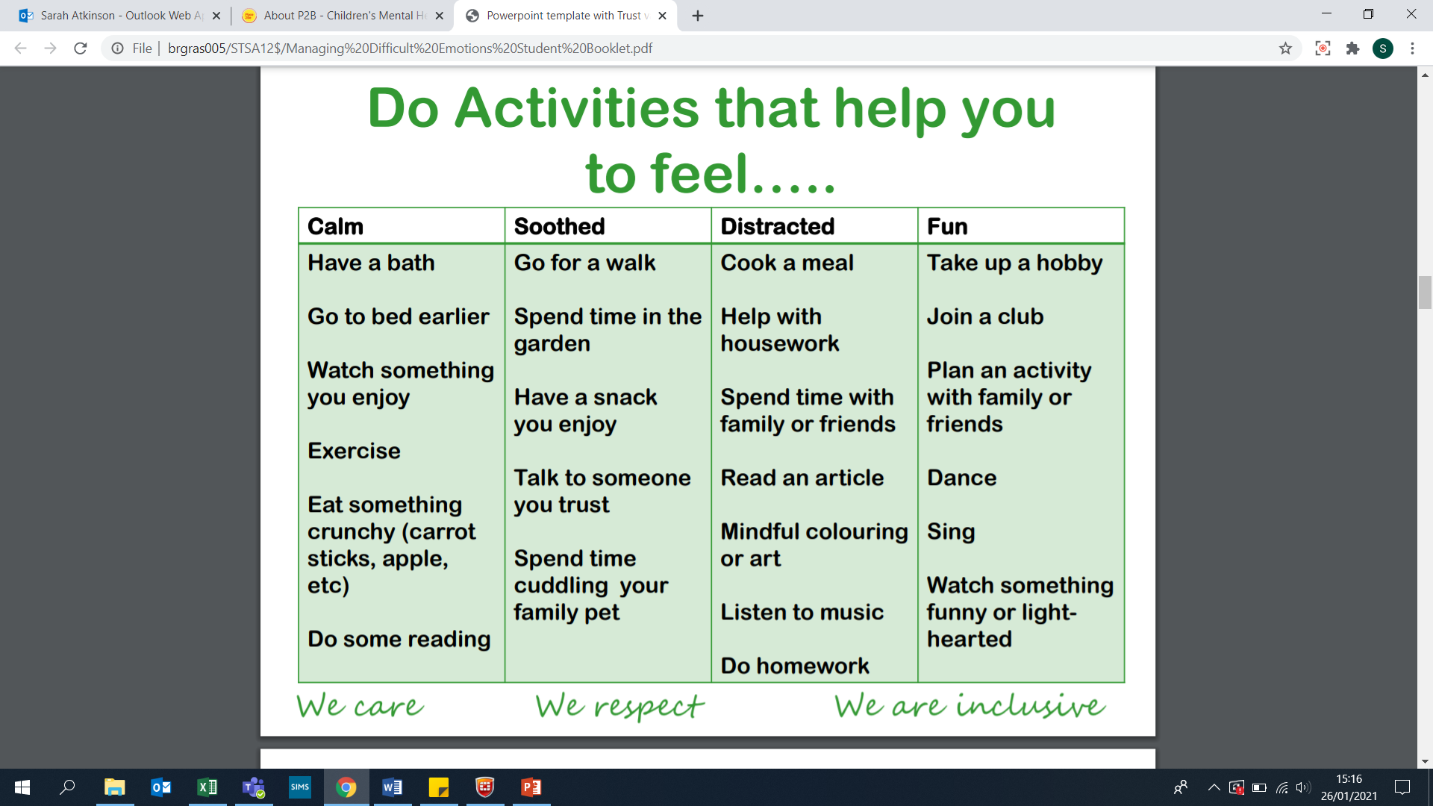

1. Creativity
2. Writing a diary/journal
3. Reducing caffeine intake

**Useful organisations**

Mind – [www.mind.org.uk](http://www.mind.org.uk) TEXT 86463

Childline – [www.childLine.org.uk](http://www.childLine.org.uk)

Anxiety UK – [www.anxietyuk.org.uk](http://www.anxietyuk.org.uk) TEXT 07537 416 905

CBT Online – [www.getselfhelp.co.uk](http://www.getselfhelp.co.uk)

**Useful Apps for self-help**

SAM– <http://sam-app.org.uk>

Mindshift – <https://www.anxietybc.com/resources/mindshift-app>

Relaxation Methods

Anxiety is a normal emotion, and is useful to us as it keeps us safe and ensures we prepare ourselves for things that cause us concern (e.g. exams, performing on stage, playing in an important sports match).

Therefore, there will be times in our lives where we feel anxious.

You can use these relaxation methods to help reduce this anxiety so that it is more manageable. These are to be used when you notice your anxious symptoms e.g. butterflies in stomach, feeling sick, increased breathing rate.

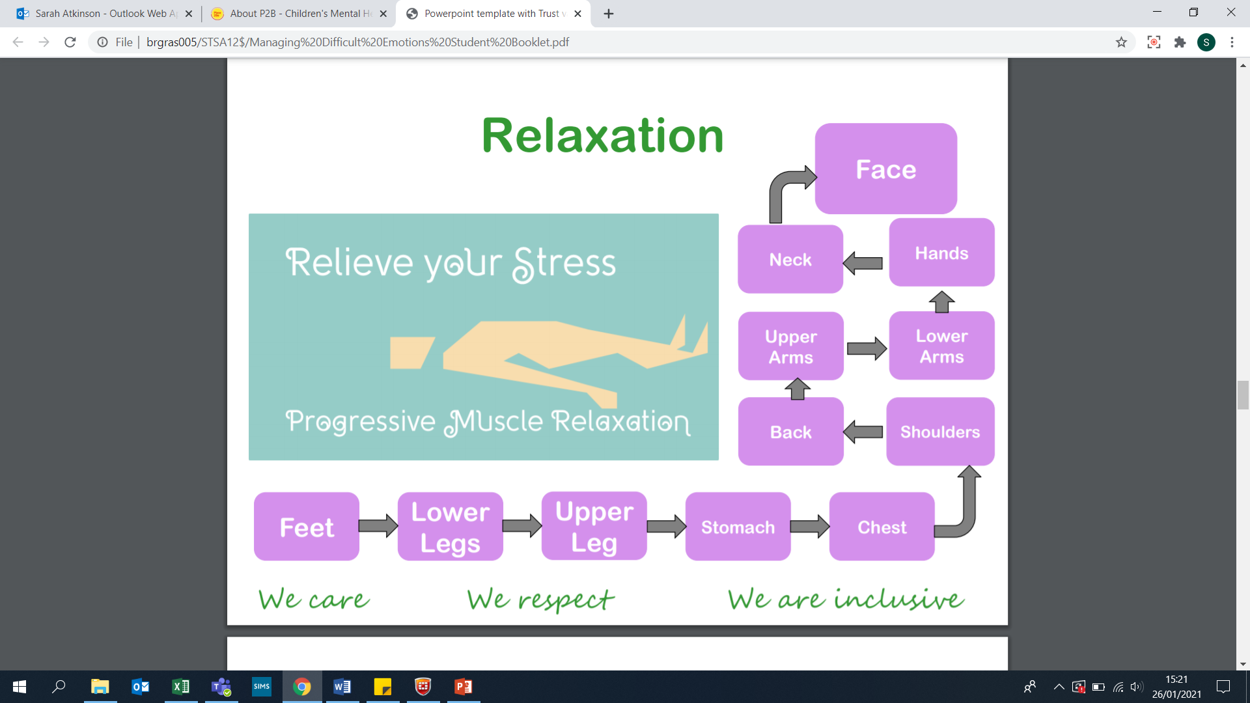

Lay down (ideally). Tense each of these body parts in order - take your time with this - and then relax.

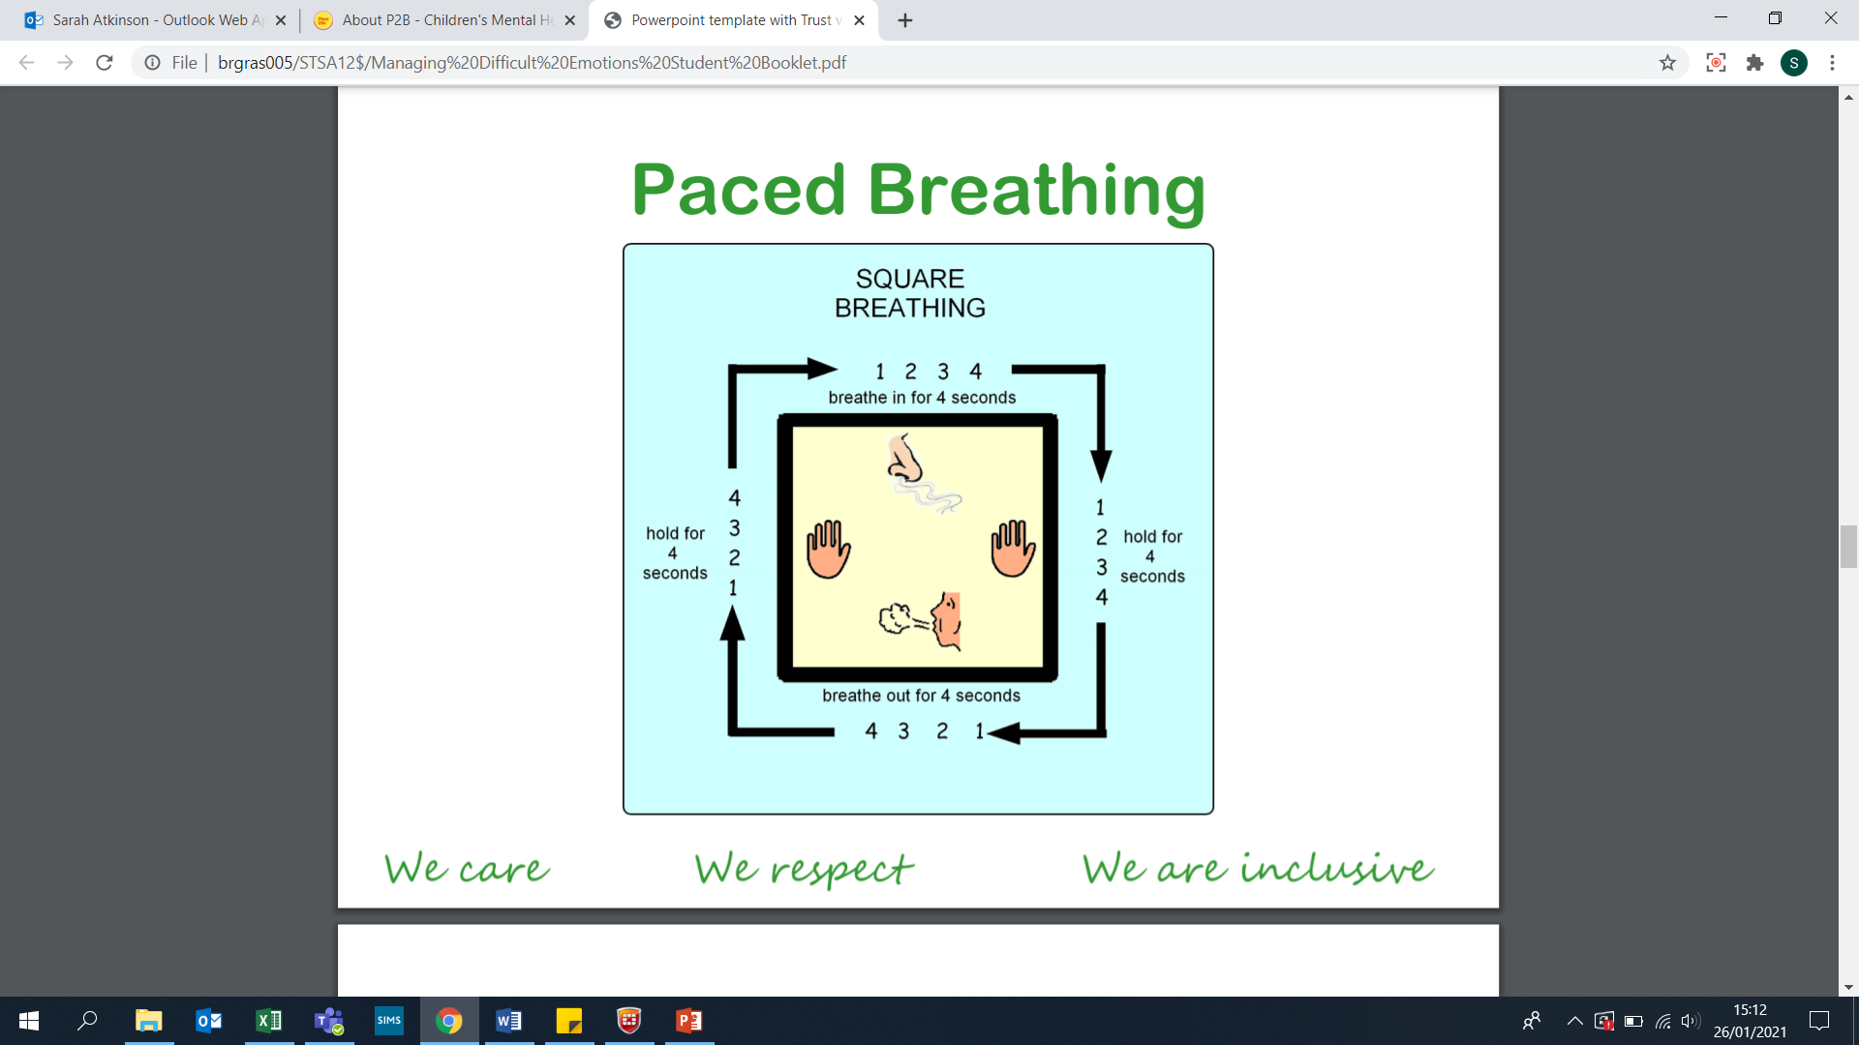

Talking

Finding a few people you can trust with how you are feeling is key, rather than talking to lots of different people. Take some time to consider who this may be (parents, siblings, friend/s, a teacher), and then allow yourself to open up. Expressing how we feel is very cathartic and can feel like a ‘weight has been lifted’.

Exercise

Simple fact. Exercise releases endorphins that make us feel better.

The challenge for you is finding exercise that you enjoy, and then ensuring you make time for it in your routine. It is also important you don’t put pressure on yourself to be particularly good at it – it is the process of completing it (rather than how fast) that is important.

Here are some suggestions, and feel free to add in your own:

* Walking, running, cycling
* Yoga (Yoga with Adriene, Sarabeth Yoga)
* HIIT workouts (Joe Wicks)
* Dance (MadFit)
* Sports – join a club, or simply take a ball down to the park.

Creativity

Being creative can be relaxing, and can also boost your mood. Have a go at some of the following:

* Drawing
* Colouring in
* Listening to calming music
* Reading
* Create a worry box (you then jot any worries down and store them here, rather than in your mind)
* Create a soothing jar – write a list of things that make you feel good and pop them in the jar. When you are feeling anxious, pull one out and make yourself do it.

Writing a diary/journal

Sometimes talking to others can be too difficult, or just might not work for you in that moment. Writing your thoughts down helps clear your mind, and can stop that sensation of having all of your thoughts whirring around.

You do not need to do this every day, although that can help, and you do not need to write an essay! You may just write some bullet points to help you manage and deal with your thoughts.

Head here for more guidance on this <https://happiful.com/4-journaling-techniques-to-support-your-mental-health/>

Reducing caffeine intake

Caffeine is a stimulant and can make us feel more awake. However, a side-effect of this is anxiety. If you drink a lot of tea or coffee, or perhaps eat a lot of chocolate, it might be worth looking at de-caffeinated options if you feel anxious often.

How can you help improve how you feel?

Now you have read the above, ensure that you really commit to trying out some of these self-help techniques – one attempt won’t immediately reduce your feelings of anxiety – and so it is important you really practise and explore the options.

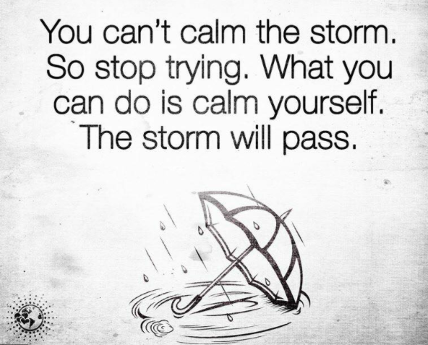

Most importantly, if you are experiencing anxious feelings all the time, and it is affecting your day-to-day functioning, then please make sure you tell a parent/carer or a teacher so that we can help you deal with this.

Look after yourself ☺