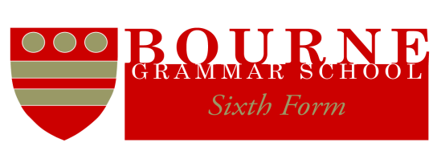

SLS/sfa

4 September 2019

Dear Parent

**Work Experience Placement during Year 12**

As part of the Sixth Form’s enrichment programme we are pleased to launch our Enrichment Programme. This will take place on a Wednesday, Week 1, Periods 4 and 5.

Your son/daughter has expressed an interest in participating in work experience or volunteering during this time. Universities and employers value those students who have undertaken a range of work experience placements during their school career. Successful placements can demonstrate attributes such as communication, team working, problem solving, organisation skills, commitment, reliability and self-motivation. Bourne Grammar School encourages its students to take full advantage of work experience and volunteering opportunities and has designed the Sixth Form Enrichment programme to meet these needs.

Students who have obtained a work experience or volunteering placement will be issued with a Work Experience booklet which should be kept up to date and signed by relevant staff during the year. These booklets should be handed in at the end of the summer term to verify that the placement has been completed.

Please complete the form below giving permission for your son/daughter to be off-site during Periods 4 and 5 on a Wednesday, Week 1 (afternoon).

We wish that as many of our students as possible will participate in this opportunity to strengthen their personal development and to gain valuable skills to assist them in their chosen career paths.

Please do not hesitate to contact me should you have any further questions.

Yours sincerely

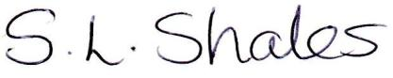

Mrs S L Shales

Head of Sixth Form

✂………………………………………………………………………………………………….

**Work Experience Placement**

Name of student: ………………………………………………………. Form: ………………...

Name of Parent: …………….........................…..…… Signed: …………………………………

Work Placement: ……………………………………………………………………………….....

Name of contact: ………………………………………………………………………………….