**UCAS APPLY 2020**

You can register yourself onto the UCAS website and begin your application for university entry 2020.

You need to go to UCAS.com and select SIGN IN, STUDENTS, UNDERGRADUATES, APPLY. Make sure that you select 2020 as the year of entry.

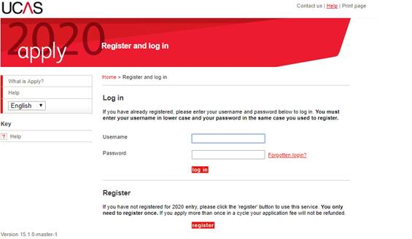

Follow the REGISTER prompts.

Please use the BUZZWORD **BourneGrammar2020** to link yourself to School.

Once you have done this you need to select a GROUP. This should be your tutor group (but with a 13 prefix).

If you have any problems then please see Mrs Hawkins.